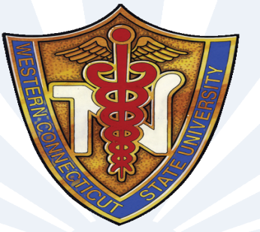 | WCSU Alumni Nursing Society
 | Western Connecticut State university Spring 2015 Newsletter
Find us on Facebook  WCSU Alumni Nursing Society  Annual Membership Dues  Annual membership dues for the Alumni Nursing Society are due each year on May 1st. Please continue to support your Society. Membership dues help with expenses such as materials, mailings, scholarships and events. Please see Membership and Pledge form enclosed. We thank you for your support.  Changed Your Name or Address Changed Since Graduating WestConn???  Please Let us know if you have changed your name address etc. Contact the WCSU Alumni office at https://www.wcsu.edu/ia/update.asp.  For more information on what is going on at WCSU go to www.wcsu.edu/alumni  Please consider donating equipment or funds to help us furnish the Nursing Labs and provide services and scholarships to all our students.  If any master's prepared alumni are interested in teaching as an adjunct or helping the nursing department, we'd love to hear from you!!!!!  Alumni Nursing Society Board Members:  Monica Sousa ‘04, ‘10  Lois Crucetti ’71, ‘97  Leah Turner ’71, ‘91  Chris Beaudoin ‘91  Michelle DiMauro ‘09  Cecilia Abreu ‘10  Kristen Lamanna ‘10  Harriet Tax Faculty Emeritus  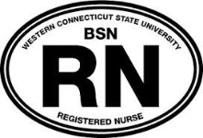  Window Decals still available. $5.00 per decal. Contact us on the WCSU Alumni Nursing Society Facebook Page if you are interested.  Hope to see you at the Annual Spring Event  April 22, 2015  4pm at Warner Hall!!! | Spring Event  April 22, 2015 at 4pm  Location: Warner Hall, Midtown Campus  Guest Speaker: Andrea O’Connor, Ed.D, J.D., RN  “Career Paths: A Tale of Three Nurses”  We are very pleased to have Andrea O’Connor speak at our Annual Spring Event. Andrea holds a bachelor’s degree in nursing from Cornell University-New York Hospital School of Nursing, a master’s degree in biophysical pathology from New York University, a doctorate in education from Teachers College, Columbia University, and a Juris Doctorate degree from the University of Connecticut School of Law. Following practice as a coronary care nurse and medical supervisor at New York Hospital, she became an Associate Editor of the American Journal of Nursing and Assistant Director of Educational Services for the company. Upon earning her doctoral degree, Dr. O’Connor served as Associate Professor of Nursing Education at Teachers College, Columbia University and Director of the Center for Nursing Leadership Development. During those years, she was a consultant to the Nursing Department at the National Institute of Health. After moving to Connecticut, she took the position of Professor and Chair of the Nursing Department at Western Connecticut State University, where she developed a highly successful master’s program. Dr. O’Connor served for many years as a member of the Connecticut Board of Examiners for Nursing, and was one of several educators who forged an articulation plan that streamlined the process for graduates of associate degree and diploma nursing programs in Connecticut to earn a baccalaureate degree in nursing.  Following an early retirement from Western Connecticut State University, Dr. O’Connor established a solo practice in elder law and became involved in local politics. She was elected to four consecutive terms as the chief elected official of the town of Sherman, and currently serves on the Board of Selectmen. She is the author of three textbooks in nursing education and staff development; recently the third edition of Clinical Instruction and Evaluation was published by Jones & Bartlett Learning. Dr. O’Connor has also written numerous articles in peer-reviewed nursing journals.  2015 Senior Class will be presenting their Senior Projects at the event.  We hope you can join us!!!  Fall 2014 Networking Event  The Alumni Nursing Society held a Networking Event, on November 19, 2014 in collaboration with the WCSU Career Development Office. The importance of networking was discussed, along with interactive group participation of the networking process. Alumni participated as group leaders and current WCSU Nursing students interacted with them. Approximately 30 participants attended.  Here are some pictures from the Networking Event. It was great to see Alumni and Nursing students working together and practicing their networking skills.  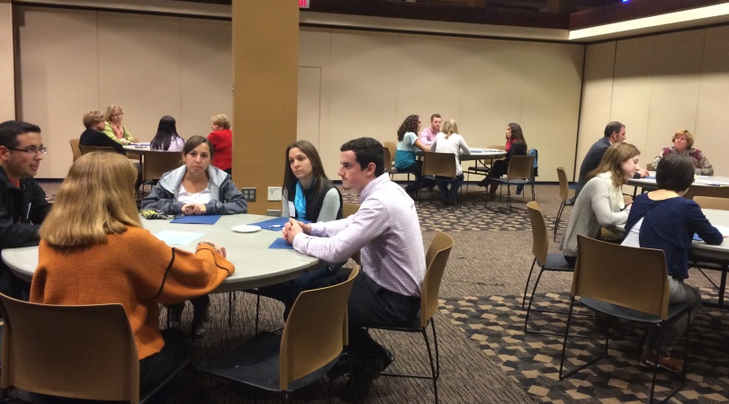  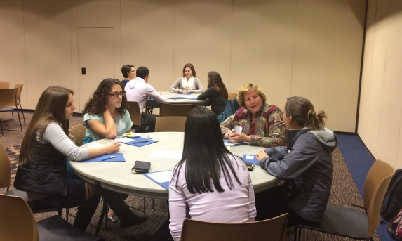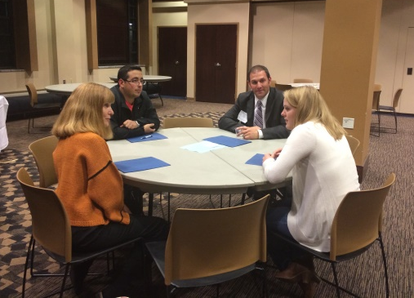  Make sure you join our Facebook page to get the latest updates on events  The Department of Nursing welcomed 65 new BSN nursing students in the Fall of 2014. Our RN/BS program has increased it’s enrollment in Waterbury and we have started offering classes on the campus of Norwalk Community College. The Master’s program in Adult Gerontological Nurse Practitioner and Clinical Nurse Specialist tracks are continuing to increase in enrollment with 20 students presently in clinical courses. We also welcomed our second cohort of Ed.D in Nursing Education students this Fall. This is a program we share with Southern Connecticut State University (SCSU) and their first residency was held at SCSU. The first cohort started the dissertation phase this past Fall.  News from the WCSU Nursing Department  There were 51 graduates of the BSN program in May of 2014. As a class, they achieved an NCLEX pass rate of 96%. There were twelve MS nurse practitioner students who graduated in May 2014. As a class, they achieved a 100% pass rate on the ANCC Certification exam.  We also welcomed new faculty members this Fall. Linda Dalessio MSN, CCRN, APRN, ACNP-BC started this Fall as an assistant professor after having been an adjunct for many years. Jennifer Ort MS, RNC and Beth Werner-Young DNP, RN, NEA-BC started as a new tenure track faculty after having been special appointments. In addition, Mary Nielson ANP-BC, DNP started last January as a tenure- track assistant professor.  Faculty have been involved with many community and scholarly activities. Monica Sousa ACNS-BC, APRN presented her research at the Connecticut Nurses Convention in October along with Christine Berte APRN-BC, CPN, Linda Warren RN, Ed.D, CCRN, and Mary Nielson ANP-BC, DNP who presented results of a joint curriculum project involving undergraduate and masters students. Professor Jennifer Ort and Dr. Barbara Piscopo brought the RN/BS students to the convention.  Monica Sousa ACNS-BC, APRN will be presenting at the 19th Annual Research Evidence-Based Practice, and Performance Improvement in Healthcare Conference in Indiana in April 2015.  Jeanette Lupinacci Ed.D, MS, BSN, CRRN, Linda Warren RN, Ed.D, CCRN, and Joan Palladino RN, Ed.D all presented at the Association for the Advancement of Educational Research Conference in Florida this past November.  WCSU nursing stays active in the Community. Nancy Carlson RN, MS had her mental health students participate in the Alzheimer’s Walk in New Milford.  Kappa Alpha Chapter of Sigma Theta Tau held its annual Fall dinner in November 2014. The speaker was Dr. Doris Lippman, professor emeritus from Fairfield University and vice- chair of the Women’s War Memorial committee, who spoke of advocacy and the role of military nursing.  Dr. Laurel Halloran has taken on the role of Department Editor for the column Current Topics in Nurse Practitioner Practice for the Journal for Nurse Practitioners. She is enjoying this opportunity to encourage and grow new authors for the journal. She would especially welcome suggestions and full submissions for Current Issues from WCSU Advanced Practice Alumni; please contact her at laurelnp@yahoo.com.

